Probability & Statistics
Lab sheet 10
Question 01
i.
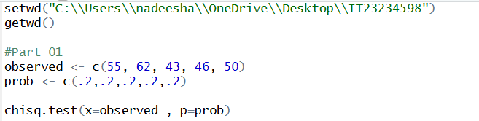
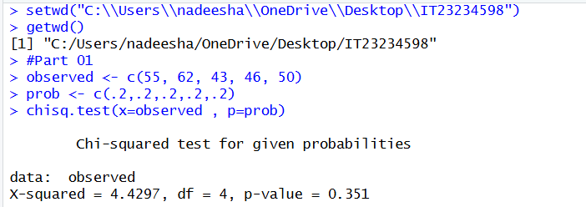
ii.
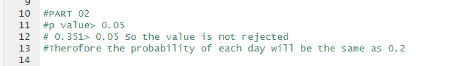
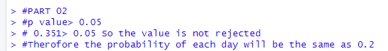

Question 02

i.

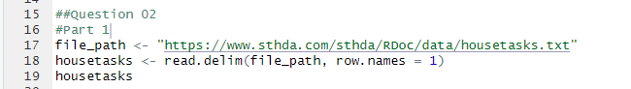

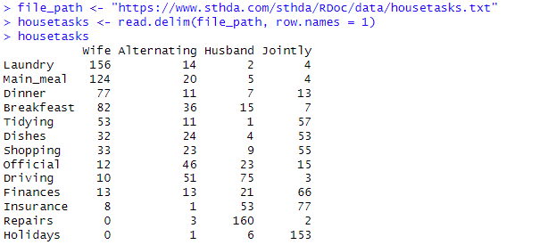

ii.
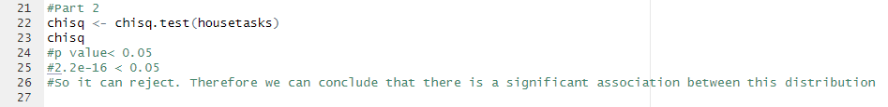

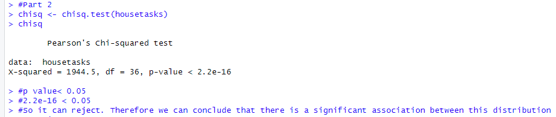

Exercise
